Assignment 6

Vanilla LSTM
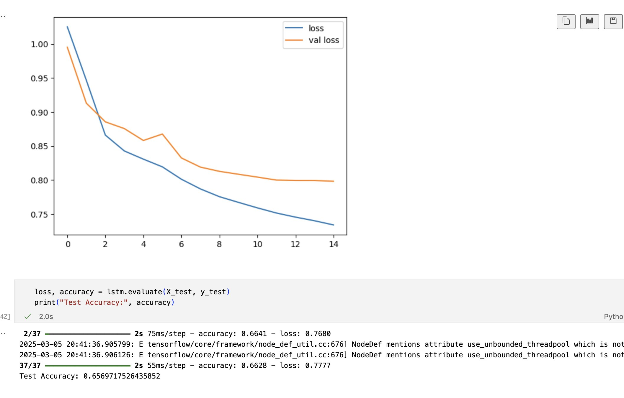
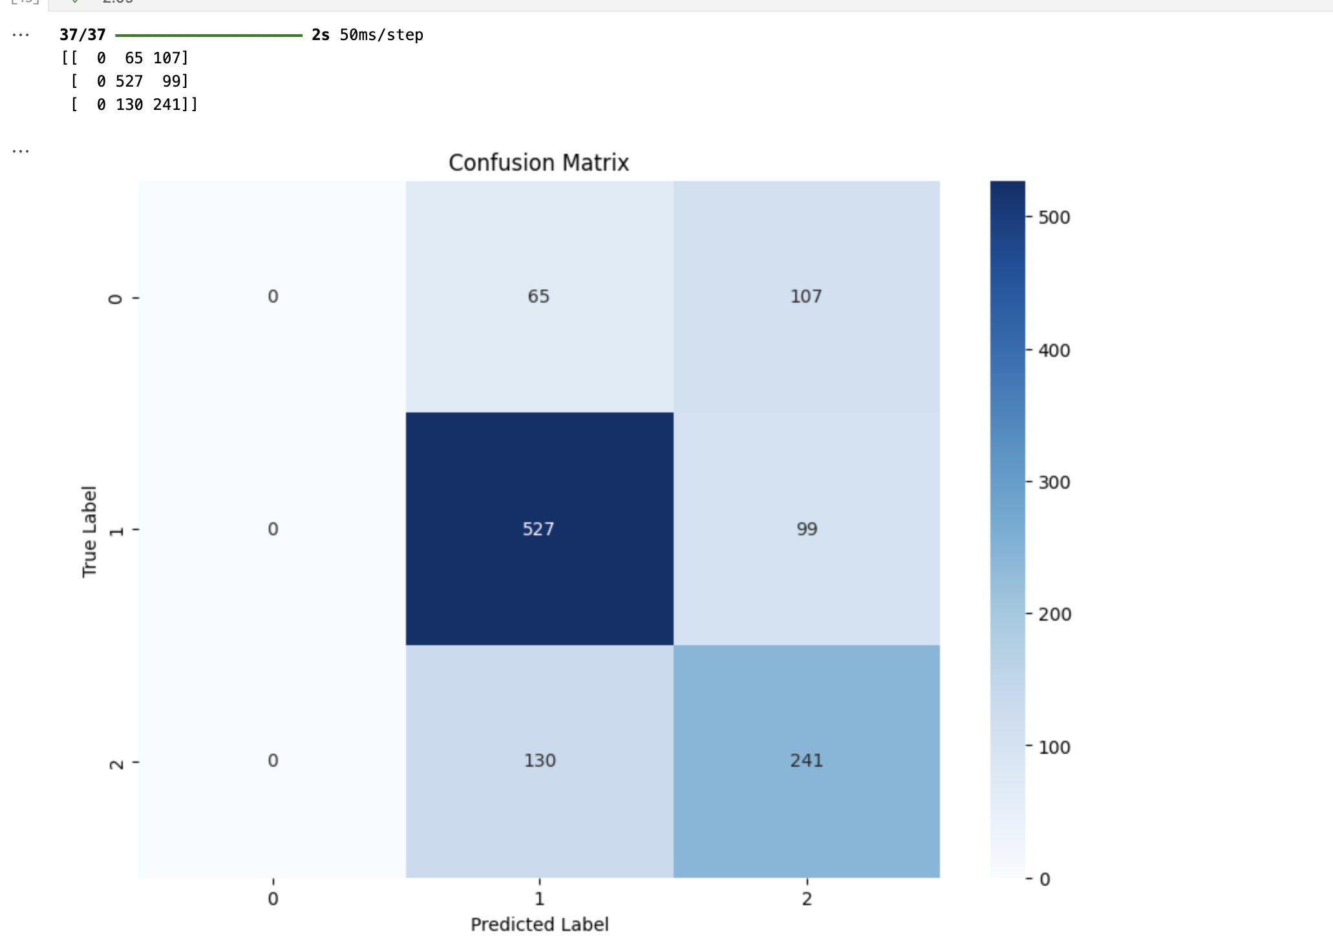

LSTM with Attention
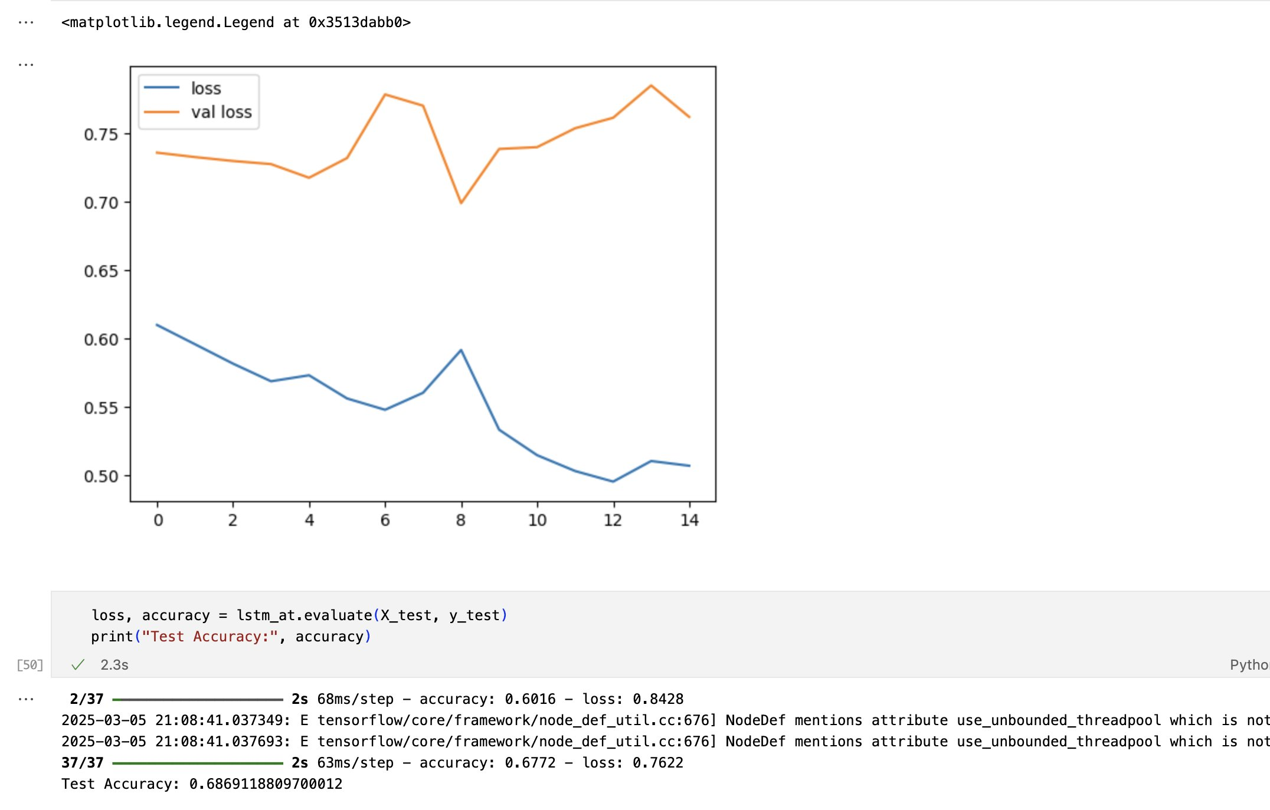
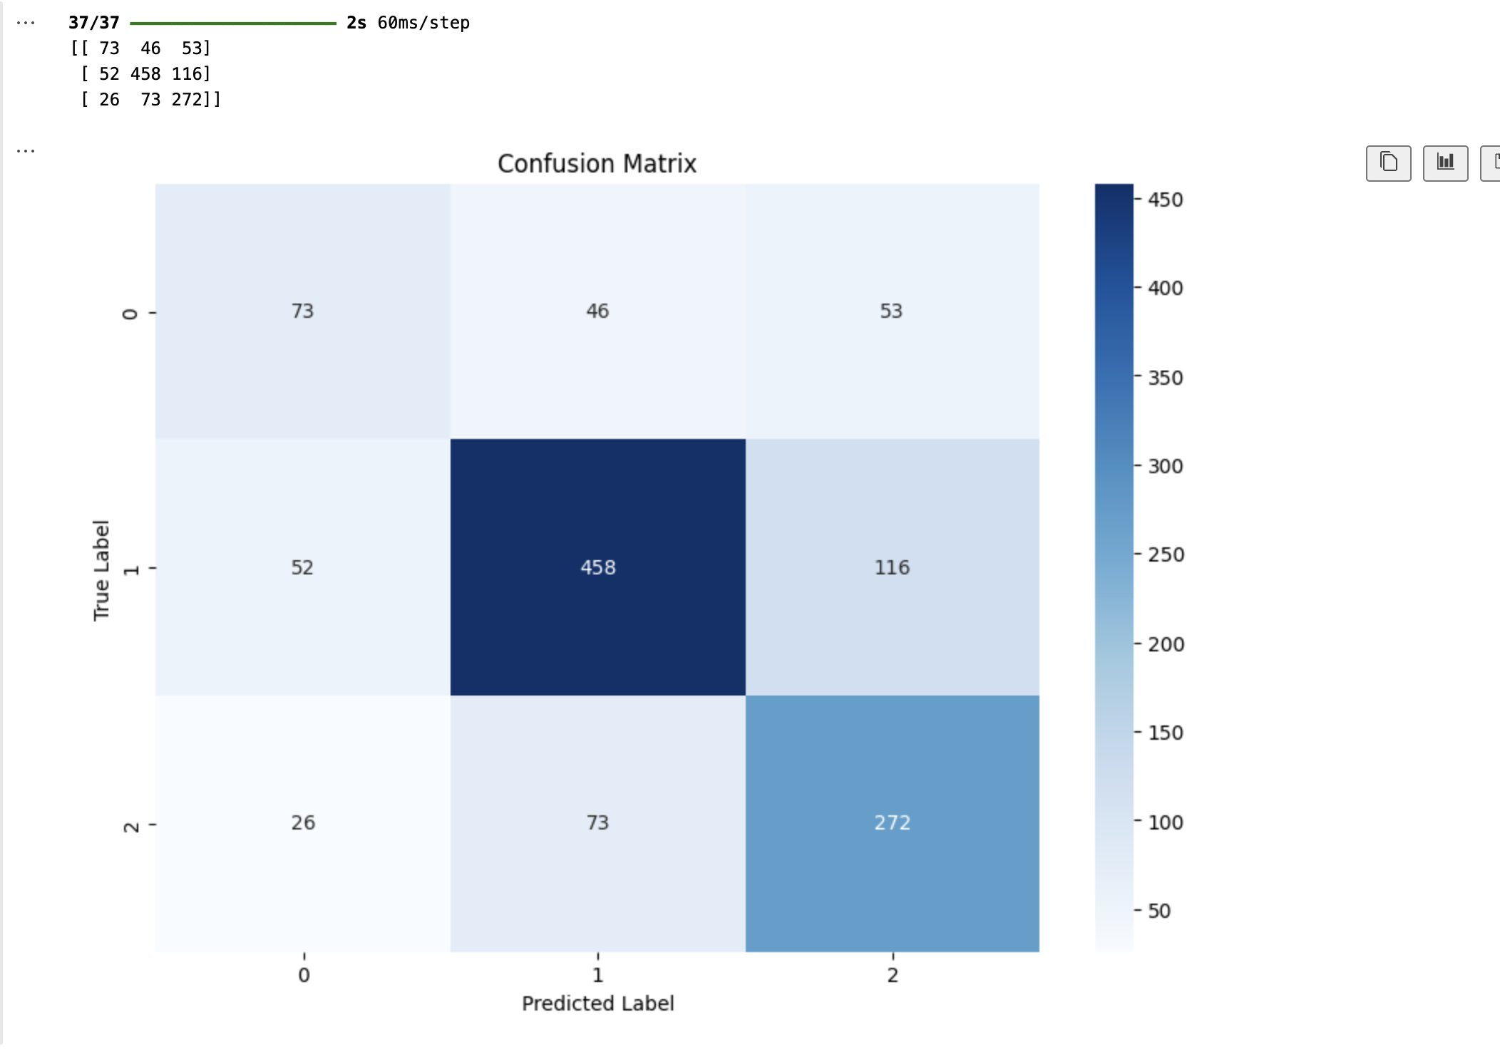

Comparison: Vanilla LSTM vs LSTM with Attention

Accuracy & Loss Comparison

Model | Test Accuracy | Test Loss
Vanilla LSTM | 65.69% | 0.7777
LSTM with Attention | 67.75% | 0.7131

Confusion Matrix Analysis
Vanilla LSTM Confusion Matrix

[[ 0 65 107]
[ 0 527 99]
[ 0 130 241]]

LSTM with Attention Confusion Matrix

[[ 73 46 53]
[ 52 458 116]
[ 26 73 272]]

Observations:
- Vanilla LSTM misclassifies most Class 0 samples (0 correct predictions).
- LSTM with Attention correctly classifies 73 samples in Class 0, showing improved handling of minority classes.
- The performance for Class 1 slightly drops in the attention model, likely due to better balancing across classes.
- Class 2 predictions is slightly better for attention model

Key Takeaways
- LSTM with Attention improves classification for underrepresented classes by helping the model focus on key parts of sequences.
- Higher accuracy and lower loss suggest that the attention mechanism enhances performance.

